Science Period __________________ Name __________________________

Assignment Section 22.1 Date __________________________

Use Section 22.1 in your textbook to answer the following questions.

Vocabulary | Give the definition & an example
- Producer
- Consumer
- Decomposer

- How is a food web different from a food chain?
________________________________________________________

________________________________________________________

- What is an energy pyramid? Why does it get narrower as you move towards the top?
________________________________________________________

________________________________________________________

________________________________________________________

<OVER>

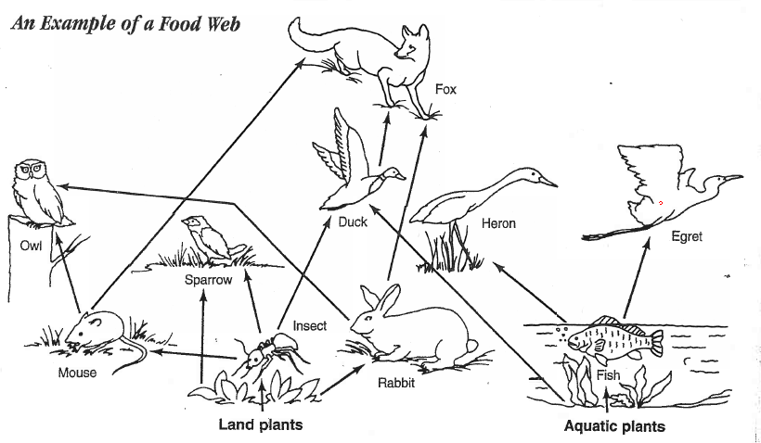
Indicate six food chains in this food web that start with plants.
- __________________________________________________________
- __________________________________________________________
- __________________________________________________________
- __________________________________________________________
- __________________________________________________________
- __________________________________________________________
Answer the questions about this food web.
- What different animals in this food web eat rabbits?
____________________________________________________________
- How does the fox indirectly get energy from food that was originally produced by land plants? ____________________________________________

