Science Period __________________ Name ____________________
Metric Conversion Date ____________________

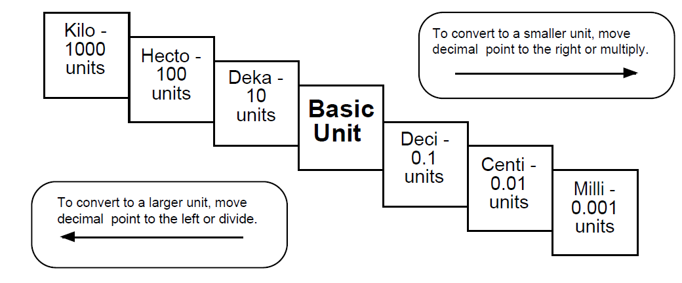
Try these conversions using the ladder method.
- 154 cm = ________ m | - 220 mm = ________ cm
- 1000 mg = ________ g | - 1 L = ________ mL
- 109 g = ________ kg | - 250 m = ________ km
- 2000 mg = ________ g | - 5 L = ________ mL
- 16 cm = ________ mm | - 198 g = ________ kg
- 480 cm = ________ m | - 75 ml = ________ L
- 5.6 kg = ________ g | - 50 cm = ________ m
Part II: Use a ruler that has metric units to answer the following questions. You must use METRIC UNITS and label each measurement with the units.
- Measure the length of this carrot and leaves in centimeters and millimeters.
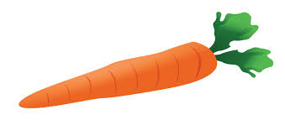
________ cm
________ mm

(www.foodandhealth.com)

- Measure the length, width, and thickness of your agenda to the nearest tenth of a centimeter.

Length = __________ Width = __________ Thickness = __________

- Measure the perimeter, distance around the edge, of this sheet of paper in centimeters.
Perimeter = __________

- Draw a 76 mm line in the space below.

- Measure the length of your pen or pencil. Choose the best metric unit. _________

- If a piece of scrap paper is 340 mm long and 25 mm wide, what is its length and width in centimeters?

Length = __________ cm Width = __________ cm

